25th BETA-IATEFL Annual International Conference
Plovdiv University “Paisii Hilendarski“, Bulgaria

TEACHING AND LEARNING ENGLISH: FROM NO TECH TO HIGH TECH.
HOW TO MOTIVATE LEARNERS

The 25th BETA-IATEFL conference took place in 3rd - 5th June 2016
The pre-conference event was titled CLIL with Young Learners

Sandie Mourão: Making the Impossible Possible - Play in English
Sandie Mourão is an independent scholar, teacher educator, author and a NILE Training Consultant from Portugal.
Typical pre-primary language focused activities led by the English teacher can support and promote independent child-initiated play in English. Sandie discussed formats, free play and autonomy and shared some research that demonstrated how English in pre-primary develops whole child. She presented how English can be integrated into the child’s daily activities and emulate pre-primary practices.

Pre-primary education
- from 3 years to official school entry age
- might not be compulsory education
- state and private education

Educational attributes of pre-primary education include
(…) interaction with peers and educators and play-based activities which can be used as learning opportunities to promote social interactions with peers and to develop skills, autonomy and school readiness.
(UNESCO-UIS, 2012 - 27)

Language education in pre-primary education
… children should be exposed to the target language in a meaningful and, if possible, authentic settings, in such a way that the language is spontaneously acquired rather than consciously learnt (p. 17)
Language learning should be integrated into contexts in which the language is meaningful and useful, such as everyday or playful situations (p. 14)
European Commission, 2011
Is language education in pre-primary about teaching content or is it about integrating language?

What is play?
Play is child’s work and means whereby he grows and develops. Susan Isaacs, 1949 9
Play is a source of development and creates the zone of proximal development. (Lev Vygotsky, 1978; 74)
Real play is essentially dramatic or make believe:
1. The creation of an imaginary situation
2. Taking on and acting out roles
3. Set of rules determined by these specific rules (Lev Vygotsky, 1978; 74)
Child-initiated play - the opportunity to explore materials and situations for oneself. (Janet Mayles, 1989; 14)

Adult-led practices + Structured child-initiated activity = Effective early years education programmes

Structured child-initiated / free play
Learning centres / Learning areas (initiated and described by Jean-Ovide Decroly (1971 - 1932) and Maria Montessori (1870 - 1952)

How can English be taught:
Usual school activities: | ELAs (Early Language Areas):
Circle time  Table time | Construction  Reading  Writing  Garage  Science  Outside  Games  House  Computer

Getting the balance between child-initiated play and adult-led play
Early language learning: Instructed foreign language + low exposure
- discrete language skills
- dissociated from other learning processes
- short period of time / week
- peripatetic English teachers

In English language teaching we use
Circle time
Table time
How can we foster child-initiated play in another language?
Is it possible to balance teacher-led and child-initiated play-based activities in target language use and development?

English learning areas (ELAs) - different spaces for children in all above mentioned spheres (Construction, Reading, Writing, Garage, Science, Outside, Games, House, Computer)
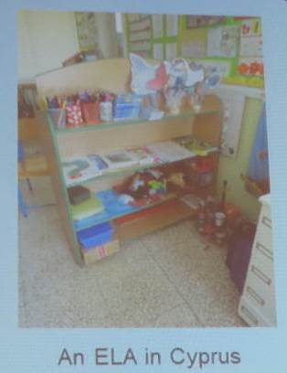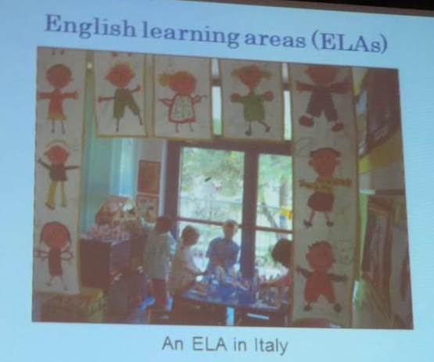

Collaboration:
English teacher - Language mediation and resources
Pre-primary professional - Space and time

What do children do?
Anecdotal evidence from pre-primary teachers:
- they imitate the English lessons
- play with resources
- invent games
- correct each other
- use English and MT
- there’s evident motivation

Interviews with children, conducted y the means of a Teddy bear who wants to know: - What is English?
- Why do you have to learn English?
- What do you do in English?

What do children do: - I play there sometimes
- I play with the English puppet
- I read stories
- I play with the dice, bingo and noughts and crosses
- I learn words in English and then I play games in English
with the dice and I say ‘I’m the best‘
- I like the game where we hide an object or an animal
and the other one has to guess
- I can choose one of the games to play and I play lots
of things

Beware!
We can play for children’s play
But we cannot plan children’s play.

Development of capacities
Social, cognitive and linguistic lead to child’s autonomy.
Autonomy is a capacity - for detachment, critical thinking, decision making and independent action. (David Little, 1991; 5)

Principle 4 of early childhood education
Children learn best when they are given appropriate responsibility, allowed to experiment, make errors, decisions and choices, and are respected as autonomous learners. (Tina Bruce, 2011; 47)

Formal instruction
Adult-led play → child-initiated play → mastery, practice, revision → restructuring accommodation → accretion (Janet Moyles, 1989; 16)

Implications for planning and implementing an English programme in pre-primary
Collaboration
- setting up the ELA
- language mediation and resources (Et)
- time and space (Ppt)
- provide feedback (Ppt)
- share information for assessment (ppt)

Implications for planning and implementing an English programme in pre-primary
The English learning area
- resources
- replicate English sessions
- attractive and lasting
- bought or made
- teacher created or child created

Play
- value play
- value different types of play
- solitary play
- cooperative play
- symbolic play
- enable play in all contexts

Progression
- Observation opportunities
- looking at progress
- planning progression

Why learn another language? (an interview)
- to learn.
- It’s to know another language, so I don’t speak just my mother tongue.
- So I can know everything.
- Because we are serious people.
- So we can play.

Planning for child-initiated, free play should be part of our early years English programmes, it is essential in the creation of a rich learning environment that involves learning with and through another language. Sandie Mourao, 2014; 263
It’s about integrating the language

Formats to support child-initiated play in English
What are the teachers‘ roles?
Teacher as a mediator - directly involved in play (e.g. play tutoring)
Teacher as planner - organizes resources, space and time

Play in English:
Adult-led / directed play - formal instruction, requires whole class interaction - interaction with teacher and peers
Child-initiated / free play - informal instruction, group - pair interaction, interaction with peers

Teacher as a mediator - play tutor:
1. a sequential structure
2. clearly marked roles
3. Scripts to support communication

A format example:
Flashcards are face-up in a row on the floor
Teacher: Let’s play What’s missing? Close your eyes!
Cc: (cover their eyes with their hands)
Teacher: (Turns a flashcard face down) Open your eyes. What’s missing?
Cc: (Call out)
Teacher: Raise your hands.
Cc: (Put hands up)
Teacher: Diogo, what’s missing?
Diogo: (A) triangle.
Teacher: Is it a triangle?
Cc: Yes!
Teacher: (Turns over flashcard) Yes, it’s a triangle. Very good.

Sequential structure
1. Teacher asks children to close their eyes
2. Teacher takes away a card
3. Teacher asks children to open their eyes
4: Children guess the missing card

Script:
Let’s play What’s missing? Close your eyes! No cheating!
Open your eyes. What’s missing?
Raise your hands.
A (object)
Is it a (object)?
Yes, it is. / No, it isn’t.
Children have language to use when the English teacher is not present in a school.

When children are not exposed to English, they still do the activities, they “play make-believe English lessons“, using the structured, acquired language.

Stefka Kitanova
Eggs. For Science. For Fun. For Kids.

Why eggs?
Because they are perfect.
We can talk about shapes, colours, origin (Which animal…?), compare the sizes (ostrich vs finch), interesting facts (1 ostrich egg equals 23 hen eggs - can you imagine how many people could eat an omelette from just one egg? :-)
Different kinds of eggs (turtle ones, chameleon ones)
One egg grows in a hen for … days. When you boil it and cut with a very sharp knife, you will be able to see the rings - one for each day…
Eggs in poetry
Eggs in art
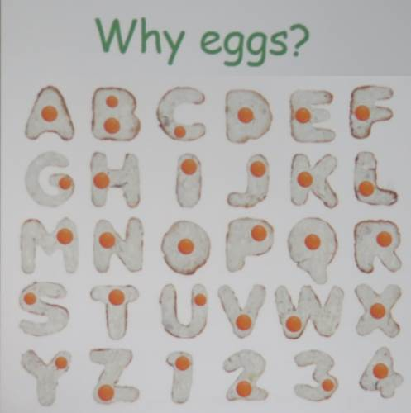

Zhivka Ilieva, Dobrich College, Shuman university
CLIL or an Integrative Approach to Teaching English to Young Learners
Zhivka Ilieva is an associate professor at Dobrich College, Shuman University. She teaches English, Methodology, Children’s literature in English and she is a teacher trainer
In her talk, Zhivka presented a programme based on cross-curricular integration introduced in kindergardens and 1st grade classes. The teachers can use free on-line materials, books and activities they use during other subjects which enables them to combine integrative links.
She introduced a lot of worksheets with different tasks that make children think and learn.

Using digital tools in the EFL classroom to develop learner autonomy
Prof. Dr. Christian Ludwig, University of Karlsruhe

Learner autonomy is characterised by a readiness to take charge of one’s own learning in the service of one’s need and purposes. This entails a capacity and willingness to act independently and in co-operation with others, as a social, responsible person. An autonomous learner is an active participant in the social processes of learning, but also an active interpreter of new information in terms of what she/he already knows. (Dam, Eriksson, Little, Millander, Trebbi, 1990; 102)
Autonomy is “the learner’s psychological relation to the process and content of learning - a capacity for detachment, critical reflection, decision-making and independent action. (Little, 1991; 45)
Developing learner autonomy:
Teacher directed and student directed planning what to do, carrying out the plans, evaluating the insights gained and new planning through dialogue and negotiation.
Why do you play video games?
Evolutionary factors
- storytelling
- skills practice
Behavioural, psychological and physical factors
- motivation
- flow
- goals, challenges and rewards
- challenge and mastery
- fantasy
- personal empowerment
- stress relief
- social contact

Digital game-Based learning
- Fun at last!
- Meet the challenges of the Games Generation:
1. twitch speed vs. conventional speed
2. Parallel vs. linear processing
3. Graphics vs. text first
4. Random access vs. step-by-step
5. Connective vs. standalone
6. Active vs. passive
7. Play vs. work
8. Payoff vs. patience
9. Fantasy vs. reality
10. Technology-as-friend vs. technology-as-foe

Life‘s a video game
Life is a video game,
Or so it seems.
It’s difficult, hard to beat.
Just don’t give up right away,
Beat the game.
But always remember,
Once the game has been beat,
You’re dead.
Never to come back alive.
It’s done there, nothing left after.
So enjoy the game while you’re playing,
Making it last a while.
Don’t pass up a level,
Don’t cheat the game,
Take your time.
Kaylynn Rose (19 July, 2012)

Conclusion:
Developing learner autonomy is an on-going process.
Multi-level collaborative learning is vital for fostering learner autonomy.
Processes of group creation, group discovery, group negotiation, and group sharing are inherent to the process of becoming more autonomous.
Digital media can give learners more genuine room to build a community of practice and to act as agents who construct the terms and conditions of their learning within this community.
Opportunities to interact and negotiate meaning (agency)

Kristina Laova
When all Other Means of Communication Fail, Try Words
Diverse speaking activities
- imitative performance (repetition)
- memory games
- look, listen and repeat
- songs, chants
- re-telling a story
- intensive performance (drills) - reading out loud
- responsive performance (questions - answers) - guessing games
- extensive performance (monologue) - re-telling a story / picture description
- drama activities (acting out, role play, simulation)

Popular activities to develop speaking:
- questions and answers - spot the differences between two pictures
- picture clues - sequence pictures in chronological order
- role play vs acting out
- miming
- simulation
- memory games
- jigsaw tasks
- twenty questions (bar Kokhba)
- interviews
- for and against (debates)
- projects
- monologues
- online audio communication and video interaction (Skype, ICQ, MSN, Facebook)

Opponents of correction
- teachers correct inconsistently, sometimes wrongly
- students are sometimes hurt by being corrected
- students may not take corrections seriously
- correction may interfere with fluency
- learners do not learn from the correction
A coach is someone who can give correction without causing resentment. (John Wooden)

Error correction stages
- detection
- identification
- interpretation
- correction
- prevention

Ways of corrections
- self-correction
- peer correction
- teacher correction

Verbal dealing with error correction
- recast
- denial
- clarification request
- repeating
- echoing
- metalinguistic feedback
- questioning
- ignoring
- non-intrusive immediate feedback
- delayed correction
- grammar auction
- error dictation

Non-verbal correction
- timelines
- personalisation

Non-verbal ways to do error correction
To interrupt or not to interrupt?
Immediate or delayed correction?

Sandie Mourão: Pictures, Words and the Gaps between - a No Tech Resource for the Classroom

Picture books:

Simple:
1. Selected for pre-school and primary ELT
2. Illustrations synchronize with words
3. Illustrations are pleasing
Č. Contain predictable, repetitive cumulative language
5. Concept books covering common primary themes
6. Provide secure supportive learning contexts

Complex:
1. Not usually suitable for ELT
2. Illustrations expand and contradict words
3. Illustrations are sophisticated and give multiple opportunities for interpretation
4. Contain rich repertoires of vocabulary
5. Cover themes suitable for older students
6. Challenge students

Example:
We all know the story The house that Jack built.
Look at this title: THE HOUSE THAT CRACK BUILT
Think of three images and three words that might appear in a picture book with this title.
Write them down.
The shocking and thought provoking story followed about the drug trade and cocaine addiction
(read about the story here )

Sandie Mourão showed a few more examples of students‘ variations of the story:
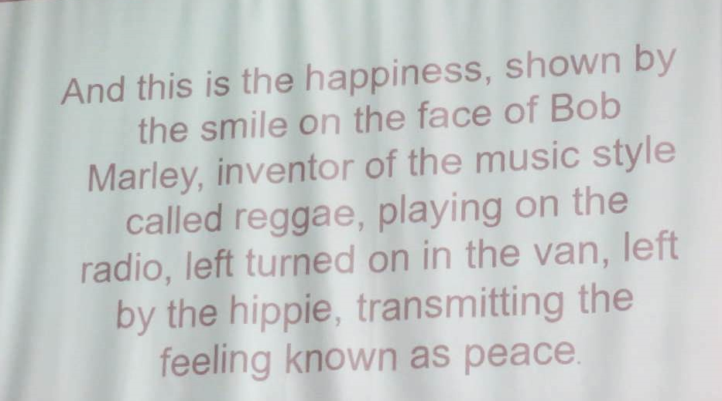
And she ended with a conclusion that picturebooks stimulate the imagination and make our students think.
They contribute to developing positive attitudes towards language learning, literature and the world around us.
Picturebooks provide appropriate, authentic learning affordances, resulting in authentic responses and language use for learners of all ages.

Syana Harizanova
Using the English Classroom for Developing Soft Skills
The English classroom can contribute to the process of developing social emotional learning in children as an integral part of curriculum and helps them to grow happier, better and more successful people tomorrow.
What are the “soft skills“?
- communication skills
- decision making
- self-motivation
- leadership skills
- team work
- creativity and problem-solving
- critical thinking
- autonomous learning
- time management and ability to work under pressure

Soft skills - what are they?
- common sense
- a sense of humour
- good manners
- optimism
- empathy
- the ability to be assertive without being aggressive
- the ability to be kind and respectful even when there are disagreements

Why use the English classroom?
- English teachers overall aim is to develop students‘ communicative skills in English and communication is the key concept when talking about soft skills
- very often communication skills are culture-specific. So it is worthwhile to raise children’s awareness of what is appropriate and what is not in Culture 1 and Culture 2 at an early age.
- primary (English) teachers are not just ‘language‘ teachers - they are educators. An English lesson can incorporate activities that can have a deep impact on a child’s social and emotional development.

When developing soft skills in the primary classroom, we need to:
- take into consideration the children’s age, level and overall development
- integrate smoothly and naturally soft skills with the other aspects of learning
- select / design activities that allow active, experimental, hand-on learning.

Some strategies for developing SSs
- model manners (!!!)
- assign classroom jobs
- design large and small group activities
- introduce big buddies
- plan and carry out explicit instructions
- play games that involve give and take
- work on a “thinking story“ - one that raises moral, personal or philosophical issues (friendship, fairness, freedom etc.)
- ask questions that provoke alternative responses e.g. Is it OK to lie? When would it be OK to lie? Think of a good reason to reveal somebody’s secret.
- link a textbook topic to a practical task, e.g. choosing a birthday present according to someone’s likes/dislikes, planning shopping within a certain budget

Aleksandra Zaparucha
Fun with Drama for All Ages
This workshop presented useful drama techniques to warm up vocal cords, body and brain. The activities practised all language skills as well as memory, spatial thinking in a relaxed, friendly atmosphere.

Desislava Terzieva, Zhivka Ilieva
Play with Very Young Learners
A compilation of activities that keep children on toes; songs with movement, TPR, worksheets.
The lively presentation turned into a discussion about assessment practices, which might be a good topic for next conference.

I would like to thank the Czech Association of the Teachers of English (ATECR) for enabling me to represent them at the conference
and
BETA Bulgaria for their kind hospitality and warm welcome with which they hosted all representatives at their wonderful event.
I really enjoyed the event and the whole visit to Bulgaria; I found a great, picturesque country with sincere people, friendly atmosphere and splendid guests, nightingales at night and wonderful scent (lime trees in blossom and traditional roses ☺ everywhere).

Mgr. Sylvie Doláková
Masaryk University Brno and freelancer
www.sylviad.cz

